## **Cost Optimization for the Deployment of Flexibility (Demand Side Management of Industrial Electricity Consumption)**

In this project, optimization defined as finding the most cost-effective active power demands for flexibility provision (maximizing the storage during excess RE) and minimizing operational energy cost by load shifting.

Modelica (MES) agents calculate the available range of active power demand considering the available energy level of the storage. Pmin is controlled such that demand is always satisfied. However, when the energy storage is full, electrolyser is forced to work under 10% load for a predefined time. Pmax is 1 p.u. when there is an available space in energy storage; however, it strictly follows Pmin, for a predefined time, when the storage is full. For RES models, Pmax is calculated considering the available windspeed and solar irradiation in the area at that time. Figure below illustrates the inputs and outputs of the controller block inside P2X functional mock-up units (FMU). Constraints for the decision making are also given in the formulation part.

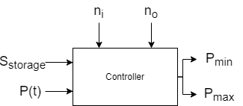

Fig. Controller block of P2X model

After agents sent allowable active power ranges to the network, Pandapower solves the optimal power flow with the cost functions, for the exact active power order of P2X within the allowable range defined by the agents. For P2G, historical intraday hydrogen/natural gas market prices (€/MWh), and for P2H, historical intraday heat market prices (€/MWh) will be considered. During excess RE, electricity price is assumed to be the cheapest; however, intraday electricity market prices can be added for more detailed analysis.

**Price based measure (Market DR):**

**Incentive based measure (Physical DR):**

* Direct Load Control

**Formulation of the optimization problem**

**Global objective**: to minimize the total energy consumption cost. Objective function runs in Pandapower with polynomial/piecewise linear cost functions.

**Objective Function:**

*subject to*

*load flow equations  
branch constraints  
bus constraints  
operational power constraints*

**Cost function:**

**Piecewise linear:**

**Polynomial:**

**Local objective:** Supply demand at all times. PID controller follows demand for Pmin calculation.,

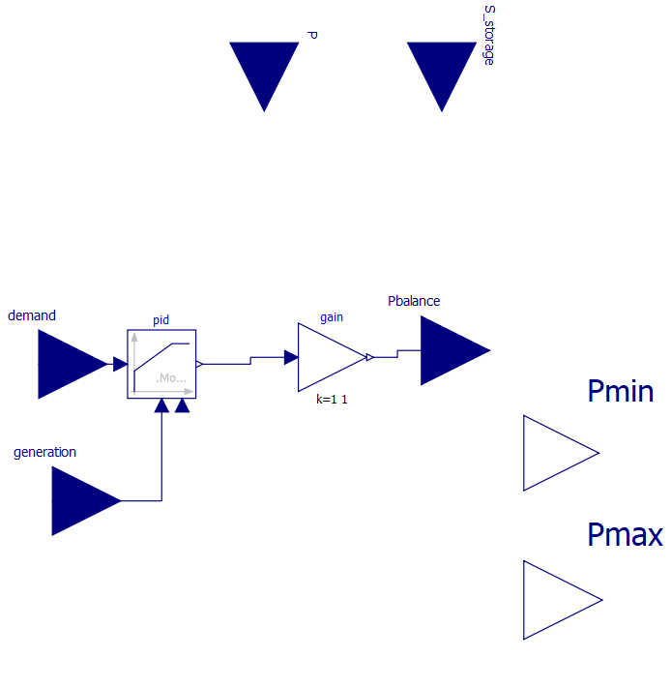

**Constraints:**

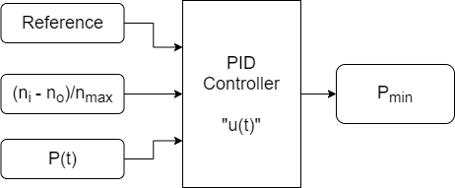

Fig. Generation/demand balance controller for Pmin calculation